SUPERIOR UNIVERSITY

THE UBUNTU TERMINAL OUTPUTS OF A PROJECT
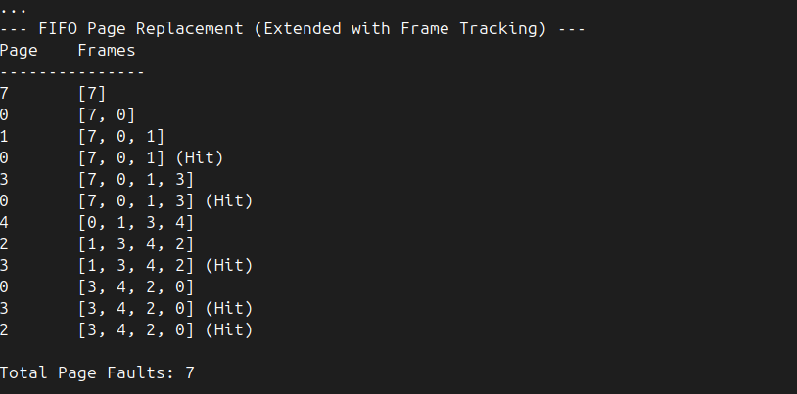
SECOND OUTPUT

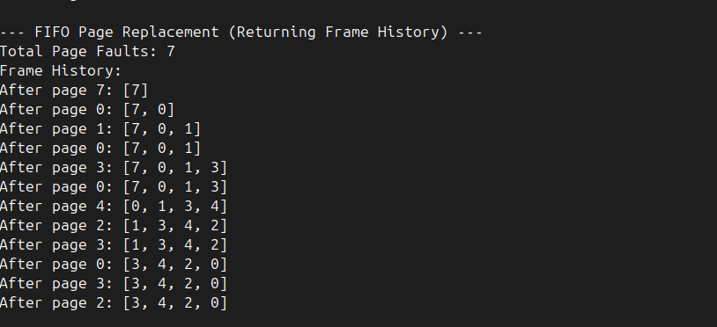
THIRD OUTPUT

